The Venture Capital Perspective on Boards
By Michael K. Lorelli

In the September/ October 2018 issue of Directorship, ‘Why PE Firms Create Boards. . . Voluntarily’ (https://read.nxtbook.com/nacd/directorship/september_october_2018/why_pe_firms_create_boards.html ) we gave a perspective from the private equity community on why 85% of the 16,800 portfolio companies have boards, despite the absence of a legal need to do so. In ‘The Venture Capital Perspective on Boards’ we offer a perspective from the view of the Venture Capital sector.
The Public company space has shrunk to only 3,600 companies with over $500 million in revenues, (source: Wall Street Journal) as a result of all the M&A in the last 5 decades. And to remind us all, private equity quietly exploded in the same timeframe, to today’s estimated 17,500 portfolio companies (source: Private Equity Info). So here’s another eye opening statistic: there are an estimated 1,047 Venture Capital firms in the US, with investments in an estimated 8,000+ companies (source: National Venture Capital Association). In this article, we offer the perspective on Boards from the view of a VC firm with multiple investments, a large VC with 33 investments today, and a VC portfolio company CEO.
But. . . why?
There clearly is no legal requirement to have these boards, and VC’s are even more penny conscious than private equity firms. Peter Londa, CEO of VC-backed Tantalus Systems states “It’s critical. Having a Board, particularly with representation from Independent Directors, leads to better decision making and is necessary to meet the fiduciary responsibility for all shareholders.” Tantalus is backed by Redpoint Partners, CT Innovations, and Discovery Capital. His board of 4 Directors consists of two Independent Directors, one venture capital firm and one company executive. Tantalus has Compensation and Audit Committees as well. Londra previously served as CEO of another venture-backed private company and an Independent Chair for publicly traded WorldEnergy.
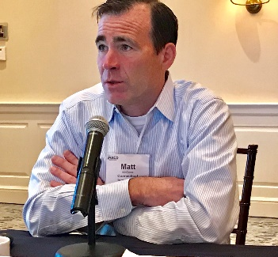
“All of the companies we invest in have, or will have Boards.”
-Matt McCooe
CT Innovations CEO

Connecticut Innovations today is the largest VC in the state of Connecticut, with investments in 185 companies. CEO Matt McCooe states “All of the companies we invest in have, or will have boards. A good Board can help management think through thorny, complicated problems. Whereas the Management team may be tackling an issue for the first time, the Outside Directors have probably been down that road eight or ten times before.” A not commonly known point about Connecticut Innovations is that they are in fact one of the most active in the state, and, are state owned. “When the company is out raising capital, maybe for the first time, the directors can show them what a first-class book should look like. And they have relationships to pull from.” McCooe adds. Connecticut Innovations boasts a positive returns from 2010 through 2018. Matt McCooe is also quick to add “Our funding bridges the gap from a great idea in a garage to product on the market. And we give young people good reasons to live and work in Connecticut’s small cities.”McCooe’s formula is a Board of at least 5, and a maximum of 7. He looks for Directors with important relationships. He personally takes a Board seat, or at least a seat as a Board Observer.
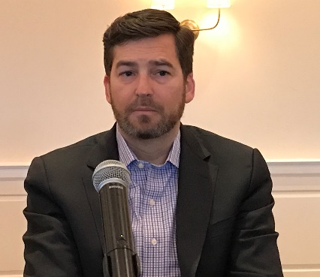
“It’s necessary to meet the fiduciary responsibility of all shareholders, not just the investors.”
-Peter Londa,
CEO, Tantalus Systems

Chris Barkley, Managing Director of Platform Ventures, which has in its portfolio the recognized brand Peloton, states rather firmly “Either they have a Board, or we create one. It’s important for governance, helps to create transparency, helps liability with LP’s, and creates a reporting relationship that is a good discipline for the Management Team.”
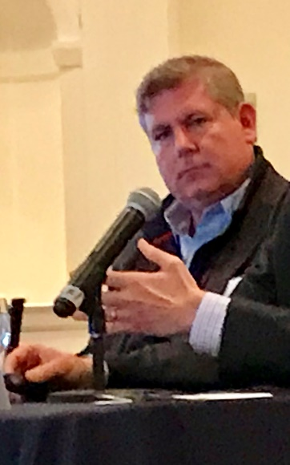
“Either they have a Board, or we create one.”
-Chris Barkley,
Platform Ventures

The Sought After Skills
Platform Venture’s Barkley looks for category expertise, with his sweet spots being consumer products, and technology enabled businesses. Tantalus’s CEO Londa says his Board “sought individuals with operating experience and domain knowledge to enhance the expertise of investors who serve as Directors, who may not have held senior leadership positions in an operating company” Connecticut Innovation’s McCooe scouts for “deep experience and a great Rolodex. But every situation is different. . . Bio or Life Sciences have very different needs than IT.”

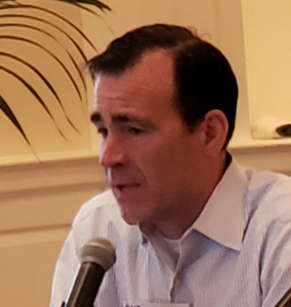
“Independent Directors are already taking on reputational risk.”
-Matt McCooe
CT Innovations CEO

How They Find Their Outside Directors
“I have fortunately been introduced to excellent Independent Directors through Investment Bankers in our space,” reports Londa. “And we leverage the networks of investors in the space. And recruiting firms often flow in candidates.” Barkley adds “We let Management nominate people they know, particularly in the space. And we leverage our own investor contacts and professional networks.”
Connecticut Innovations McCooe relies on people he already knows, and people they’ve met during their own Due Diligence process. “If we don’t already know people in the space, we probably shouldn’t be investing in the company,” McCooe quips. McCooe is clearly a ‘been-there-done-that’ guy. A good caution for anxious candidates: Matt McCooe also provides the personal thought that finding the outside directors is likely not the first thing or last thing he thinks about every day.
What Is The Compensation Model
Initially, while every VC portfolio company is starving for cash while in negative EBITDA mode, options, but no cash, seem to be the model. Tantalus initially granted their Directors a grant equal to ½% of the equity with a four year vesting schedule, and later added cash, plus additional cash fees for Committee Chairs. Platform Ventures, equally, starts with zero cash, and options usually at 1 point of equity, but adds $30K - $45K cash later, in addition to the vesting options, as the company passes the all-important cash flow positive milestone.
Connecticut Innovations sees options valued at ¼% to 2% of equity, depending on the company stage.
Meeting Frequency
The temptation seems to be, initially, very tight management. Londa reports that at inception, meetings were monthly, 90 minutes, with longer duration quarterly (reporting) meetings. “The financial and operational discipline associated with prepping for the meetings was very helpful, but resulted in up to 3 days of time for members of management to prepare materials. We migrated to 6 meetings per year, which was a huge relief. The prep workload cascades down the organization.” ”Quarterly is the standard” for Chris Barkley.
Connecticut Innovations opinion is that “Monthly is complicated.” They prefer quarterly, but with a good hour-long phone call each month.
“Ask for the audit. Is it from a reputable firm?”
-Peter Londa
Tantalus Systems CEO
Does The Independent Director Need to Invest?
Connecticut Innovations never requires Outside Directors to invest, but they’re always welcome to co-invest. Matt McCooe believes “They’re already taking on reputational risk, and their names are publicly on the website. We have to value that.” Tantalus did not require Outside Directors to invest, but the Directors (and Management) were given the chance to co-invest as the company raised capital. Barkley agrees, that its entirely voluntary, but feels “A lot of times, the new Independent Directors are eager to participate so as to improve their own return. It adds alignment of the Management Team and the Board.”
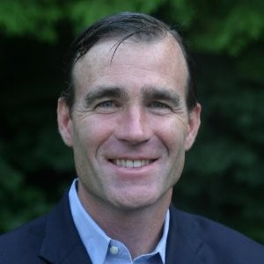
McCooe and Londa agree on the cautions in Venture Capital

How Does a Prospective Director Candidate Judge The Company’s Success?
Matt McCooe advises to first look at who the existing investors are, their track record, their values, their personalities, and whether its consistent with your own. “You want to see and feel alignment with the investors, and confidence that the CEO is a winner.” Barkley believes the best view is the company’s Balance Sheet, and a Board candidate should look for enough cash to cover the burn rate for a reasonable period of time. “And then add your own perspective on the company’s ability to scale, and in a big enough market.” Uber apparently passed that test in 2009 for some investors. Tantalus’s Londa quickly adds that VC portfolio companies report financials, as do other companies. “And ask for the audit. Is it from a reputable accounting firm? Read the audit notes!” McCooe also recommends you only go on Boards “In a market that you understand and appreciate what it takes to be successful.”

What Are The Risks Going On a VC Company Board?
Treasury-bill holders take note here: Barkley is realistic about the space- “It’s not for the faint of heart. Demand D&O insurance, and if possible, swim a little bit upstream, meaning closer to profitability.” You need a tougher stomach here. “Think about the company’s stage in the life cycle” warns Londra. “Early-stage companies are focused on proving its product viability. Then comes the effort to commercialize the business model followed by the need to generate profitable and sustainable growth. Convince yourself a potential company has a management team that can lead beyond innovating.”
Connect Innovations McCooe reinforces the need for D&O coverage. He adds “The biggest risk is the person’s time risk/ and the inherent opportunity cost of your time.”
Conclusion
- Boards are boards. The public, Private Equity, and Venture Capital spaces have different names. But the Board governance underpinning is strikingly similar. VC’s may have a greater need for category expertise, and can be tighter on cash compensation. The attraction, however, is on the potential equity appreciation. We’d all like to be on the board of the next Apple or Uber, but that foresight eludes even the Venture Capital firms themselves. Remember, HP, Xerox PARC, and IBM concluded in 1983 that there was no market for a personal PC.
- In your pursuit of Board engagements, you want to fish where the fish are, keep in mind the size of the buckets:
  - Public companies (> $500m revenue): 3,600
  - Private equity portfolio companies: 17,500
  - VC portfolio companies: 8,000

- If anything has a risk/ reward ratio, here is the perfect example. Public companies are generally long established, with very long tails. Private Equity generally invests in newer businesses, but with positive cash flows, and better returns than public companies to the investors. And Venture Capital brings the promise of the next Uber-like return. . . but investors and Independent Directors need a bit more intestinal fortitude. Directors with the time and interest in serving on multiple Boards might think about their own ‘Board Diversification Strategy.’ Perhaps one public Board, 1 or 2 private equity Boards, and one, more speculative VC backed company. But just keep in mind, that as you calculate the return on your time, as the saying goes, “your actual mileage may vary.”

Mike Lorelli served two PepsiCo President roles before segueing to private equity. He has led CEO engagements for Riverside Company, Rutledge Capital, Falconhead Capital, and Pouschine Cook Capital Management. He is presently an Operating Partner of Falconhead Capital, and is on the Boards of iControl, KPI Soft, Cannabiniers, Cardrac, and the Connecticut Chapter of NACD. He is also a private pilot and avid golf duffer. Email: MKLorelli@gmail.com +1.203.253.1238
____________________

